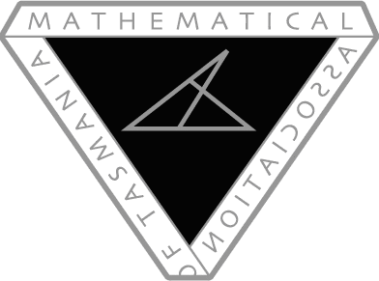

MAV Conference 2018 (Victoria):

Bursary Application

In 2018, the Mathematical Association of Tasmania is offering two bursaries for up to $750 for Tasmanian teachers to attend the Mathematical Association of Victoria’s 2018 Conference, “MAV18: Teachers Creating Impact”. This will take place on 6th and 7th December 2018. Bursaries comprise of either FREE two-day registration (approx. $750 value) OR reimbursement of travel and accommodation expenses (up to $750). This offer is open to existing MAT Members only.

Name of Applicant:

Type of MAT Membership (student, concessional, individual, institutional, life):

School/Institution:

Residential Address:

Contact Email:

Contact Phone:

Mathematics teaching experience (including year level/s taught):

I confirm that I am a member of MAT and that I have obtained my principal’s permission to attend MAV18 on 6th and 7th December 2018. AGREE/DISAGREE
Why would your attendance at MAV18 be valuable for you and your school?

The information that you provide on this form will be used to rank applications, if needed. Return completed forms to Brett Stephenson (bstephenson@gyc.tas.edu.au) by Monday September 24th 2018. Expect a reply within 48 hours. Hard copies should be scanned and emailed as an attachment.

